Experiment worksheet

5.1 Classification organises our world

Pages 80–81 and 192

Challenge 5.1: Department store classification

1 With a partner, divide the items listed below into six department store groupings of your choice. Justify your choices.

snowboard, CD , ‘miracle’ moisturiser, waterproof tent, golf balls, jeans, mountain bike, T-shirt, atlas, cricket bat, Hacky Sack, laptop computer, sleeping bag, nail polish, digital alarm clock, TV celebrity poster, backpack, surfing magazine, ultrashine lip gloss, plasma TV, winter coat, wetsuit, R&B CD box set, glitter eye shadow, perfume, swimming costume, MP3 player, travel book, CD player, hoodie jumper

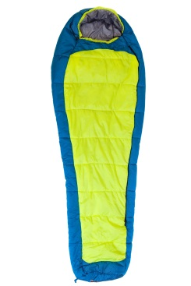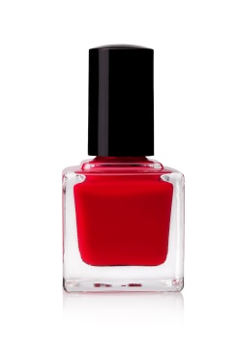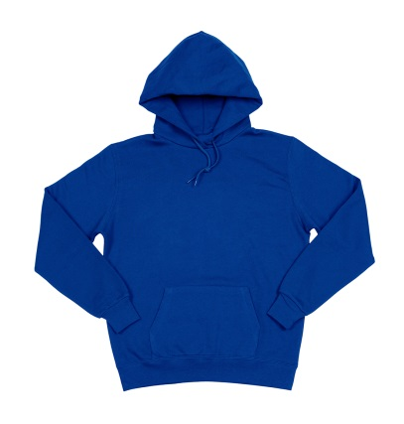

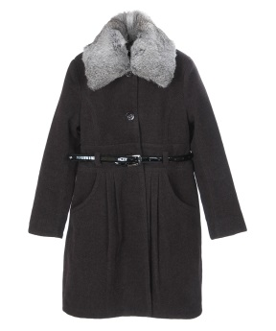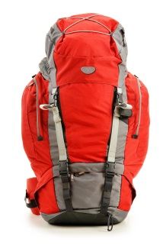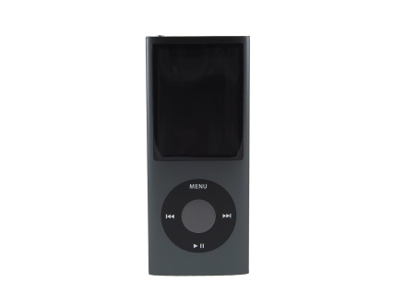

2 Divide the products in your six departments into smaller groups or ‘sub-departments’.

|  |  |  |
| --- | --- | --- |
| Department | Item | Reason for classification |
| Department 1: |  |  |
| Department 2: |  |  |
| Department 3: |  |  |
| Department 4: |  |  |
| Department 5: |  |  |
| Department 6: |  |  |

3 Draw a plan of your department store layout in the space provided. Think carefully about what departments you will put next to each other and why.

|  |
| --- |
|  |

4 Join up with another pair and ‘take them on a tour’ through your department store.

5 How is your department store different to the one prepared by the other pair? What are the advantages and disadvantages of each design?

Experiment worksheet

5.3 Classification keys are visual tools

Pages 84–85 and 193

Challenge 5.3: Dichotomous key

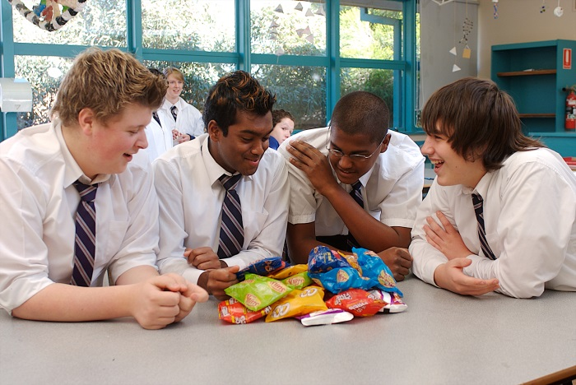Using what you have discovered about the characteristics of living things, design your own dichotomous key.

Questioning and predicting

Think about objects that could be sorted into two groups; for example, you might like to use snack foods, such as corn chips, flavoured chips or plain chips.

Planning and conducting

• What similarities or differences can you find to separate the objects into two groups?

• What other similarities or differences can you find to separate them into further subgroups?

• Keep dividing each group into another two groups until each item is on its own.

Processing, analysing and evaluating

1 Draw a dichotomous key to show how you grouped the objects.

|  |
| --- |
|  |

2 How hard was it to divide your objects into different groups? Could you have used a better group of objects?

Communicating

Swap dichotomous keys with another group. How effective is the dichotomous key constructed by the other group? Ask them to evaluate your key. Which was the best dichotomous key designed in your class? What features made it the best key?

Experiment worksheet

5.4 The classification system continues to change

Pages 86–87 and 194

Challenge 5.4: Can you understand scientific names?

The scientific names of organisms usually come from Latin (and sometimes Greek) words. Latin was the language of science for many centuries. This enabled scientists who lived in different countries and spoke different languages to communicate their work and discoveries.

The words used in the scientific names of organisms describe physical features, behaviours and even colours.

Some examples are given in the table below.

|  |  |
| --- | --- |
| Latin or Greek root word | English meaning |
| *Aculeat* | Spiny |
| *Arctus* | Bear |
| *Anatinus* | Duck-like |
| *Cinereus* | Grey |
| *Gloss* | Tongue |
| *Hynchus* | Snout |
| *Macro* | Large |
| *Ornitho* | Bird |
| *Phascol* | Pouch |
| *Pus* | Foot |
| *Rufus* | Red |
| *Tachy* | Fast |
| *Chlamy* | Caped |
| *Saurus* | Lizard |

1 Use the information in the table to match the scientific names of the Australian animals pictured on the next page.

a *Macropus rufus* _________________________________________________________________

b *Tachyglossus aculeatus* __________________________________________________________

c *Phascolarctus cinereus* ___________________________________________________________

d *Ornithorhynchus anatinus* _________________________________________________________

e *Chlamydosaurus kingii* ___________________________________________________________

|  |
| --- |
|  |

2 What do you think a *Macroglossus aculeatus* might look like? In the space provided, sketch this imaginary animal, using the information in the table to help you.

|  |
| --- |
|  |

Experiment worksheet

5.5 All organisms can be divided into five Kingdoms

Pages 88–89 and 195

Challenge 5.5: Classifying living things

The scientist whose main role it is to classify living things is known as a taxonomist. In this activity, you become the taxonomist.

What you need:

A3 card or paper, scissors, glue, pictures of different living things (from the Internet or magazines)

What to do:

1 On a sheet of A3 card or paper, or using the space below, mark up a table with four columns.

2 Label the columns ‘Animalia’, ‘Plantae’, ‘Fungi’ and ‘Other (Monera and Protista)’. (Don’t try to distinguish between Monera and Protista.)

3 Paste each of your pictures into the correct column

|  |  |  |  |
| --- | --- | --- | --- |
| Animalia | Plantae | Fungi | Other |
|  |  |  |  |

Experiment worksheet

5.6 Animals that have no skeleton are called invertebrates

Pages 90–91 and 196

Experiment 5.6: Dissecting skeletons

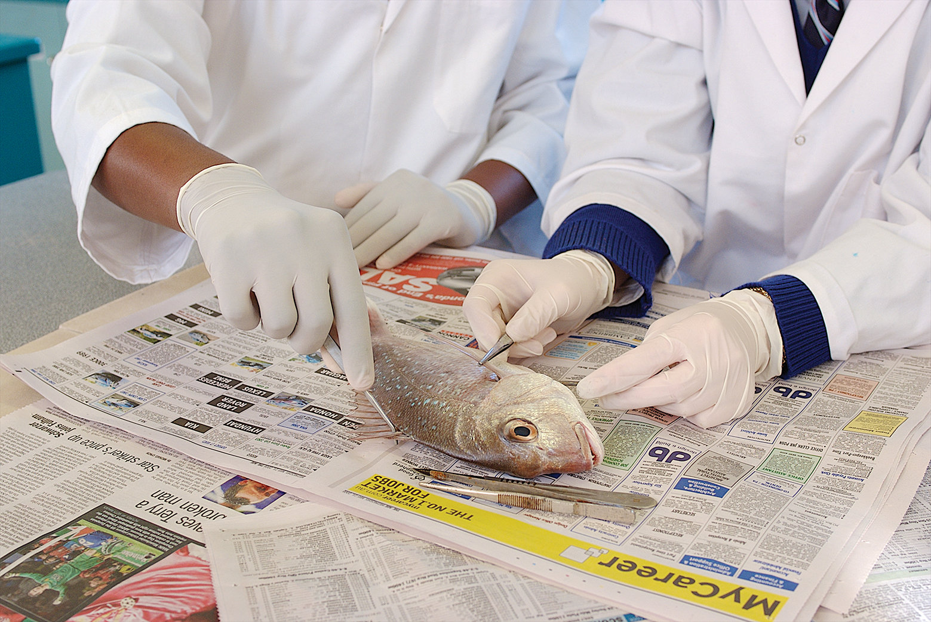

**Figure 1**

Aim

To examine the skeletal structures of three marine organisms.

Materials

• 1 fish (whole)

• 1 prawn

• 1 squid

• Newspaper

• Dissecting board

• Dissecting kit

• Pair of vinyl or latex gloves

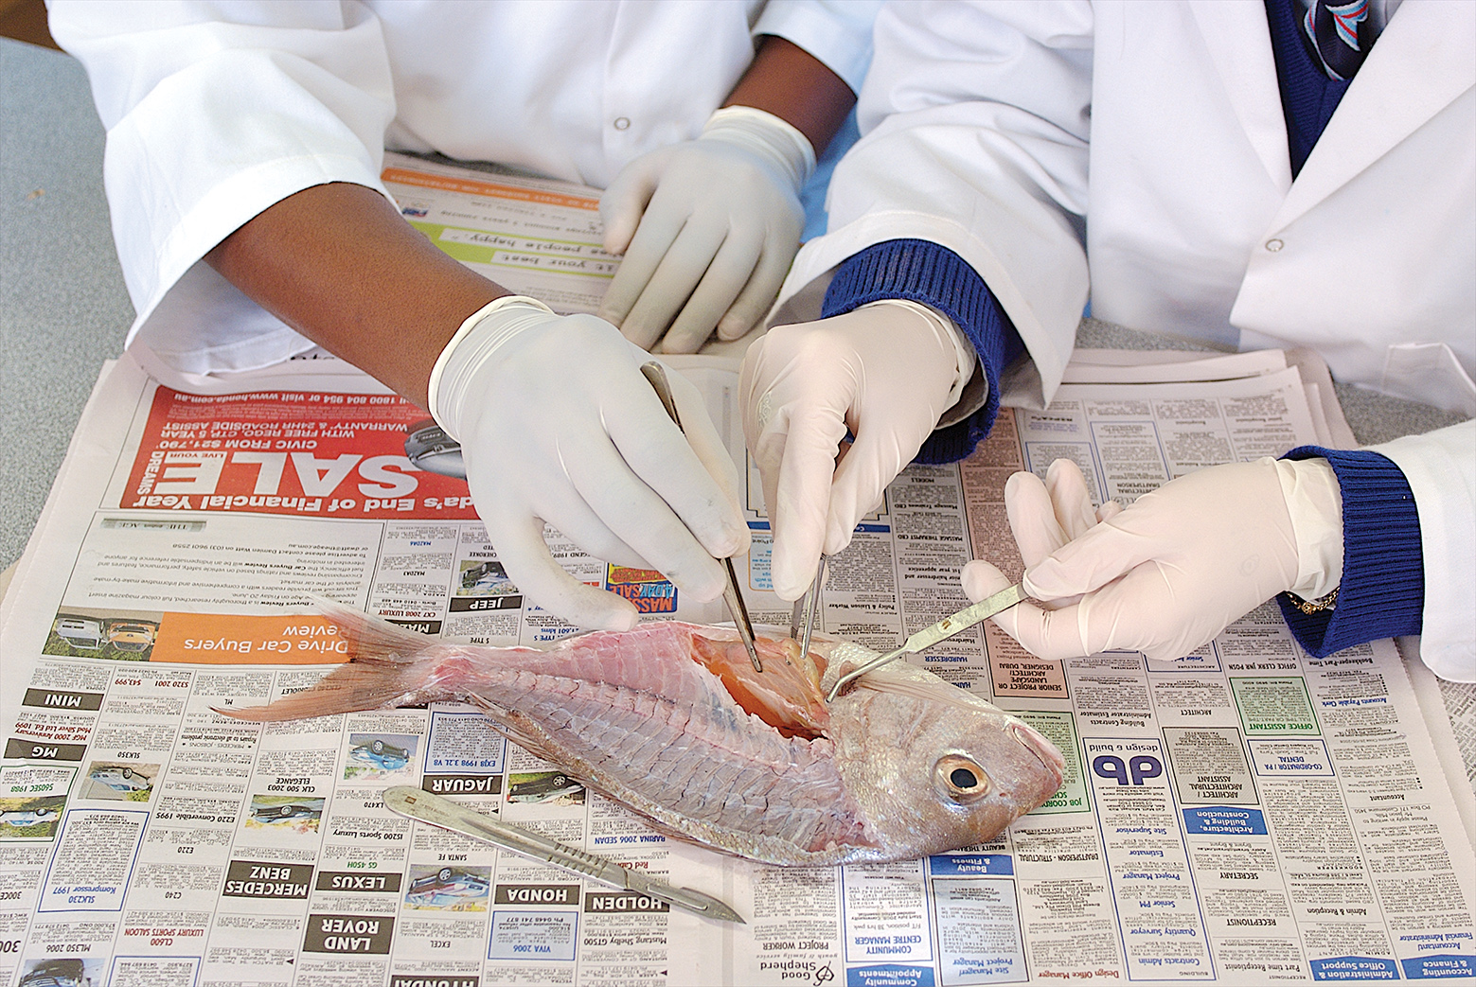

**Figure 2**

Method

1 Observe the external features of the fish.

2 Carefully cut the fish in half lengthways so you can see the internal skeleton.

3 Observe the skeleton of the fish.

4 Feel the outside of the prawn and then peel it.

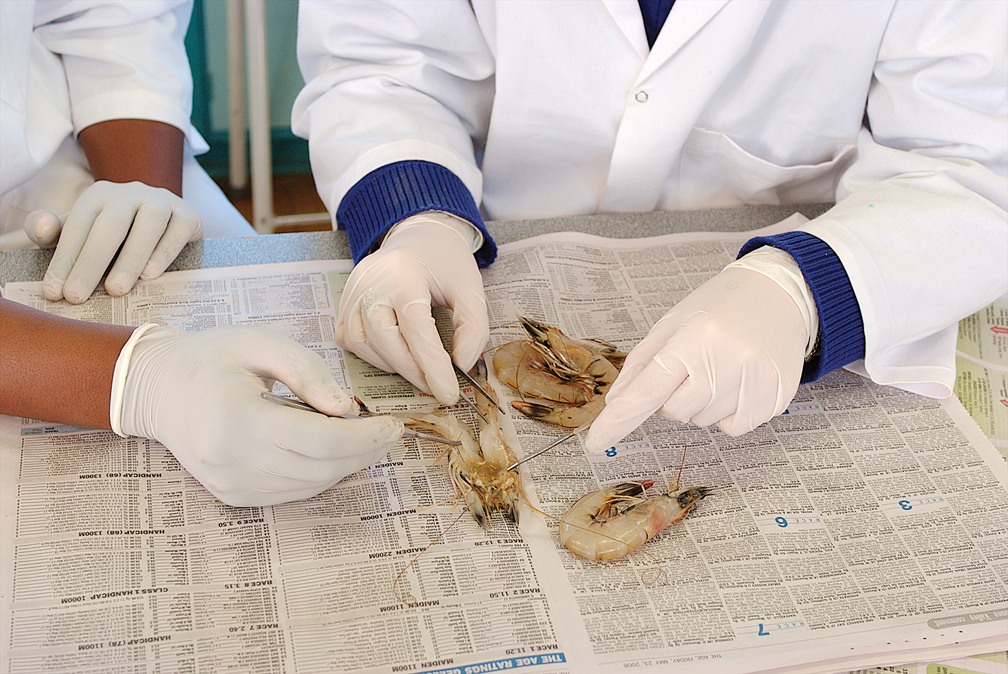

**Figure 3**

5 Cut the prawn in half and observe the insides.

6 Feel the outside of the squid and then cut it in half.

7 Observe the inside of the squid.

**CAUTION:** SCALPELS ARE EXTREMELY SHARP. USE WITH GREAT CARE.

**ALWAYS** WEAR GLOVES WHEN HANDLING THE ANIMALS.

**IF** CUT, REMOVE GLOVES AND WASH THE CUT UNDER CLEAN WATER. APPLY ANTISEPTIC TO THE CUT AND COVER IT WITH A DRESSING. TELL YOUR TEACHER.

**ANIMALS** MUST ALWAYS BE ON THE DISSECTING BOARD WHEN THEY ARE BEING HANDLED OR DISSECTED.

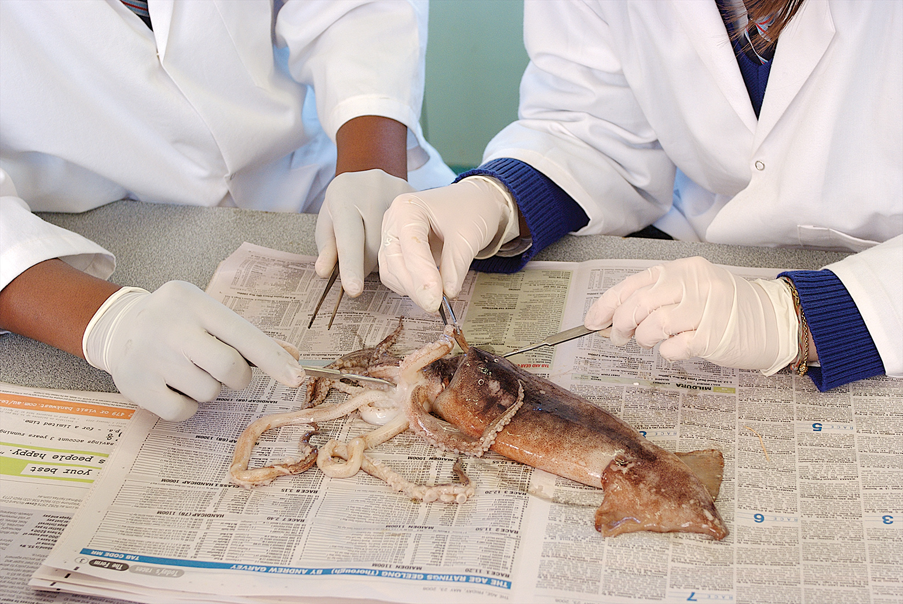

**Figure 4**

Results

Draw labeled diagrams of the skeleton of each specimen in the space provided.

|  |  |  |
| --- | --- | --- |
|  |  |  |

Discussion

1 Consider the fish.

a Where is the skeleton of the fish located? ____________________________________________

b What is this type of skeleton called? _________________________________________________

2 Consider the prawn.

a Where is the skeleton of the prawn located? ______________________________________

b What is this type of skeleton called? _________________________________________________

3 Does the squid have a skeleton? __________________________________________________

4 In which group of animals (vertebrate or invertebrate) would you place each of the organisms observed? Why?

5 What are you: a vertebrate or an invertebrate? ____________________________________________

Conclusion

What types of skeleton are possible?

Experiment worksheet

5.6 Animals that have no skeleton are called invertebrates

Pages 90–91 and 197

Challenge 5.6: Identifying invertebrates

What you need:

Magnifying glass or stereomicroscope, Petri dishes, jars with lids, tweezers, vinyl or latex gloves, newspaper

Alternatively, your teacher may provide prepared samples for you to look at. Complete the classification exercise for each prepared sample.

What to do:

> Do not touch any animal that might bite or sting. Check with your teacher if you are unsure.

> Use tweezers to pick up the animals.

> Place any animal immediately in a jar and secure the lid.

1 Visit a local natural environment (e.g. a garden, beach, park or pond) and observe invertebrate specimens.

2 Wearing gloves, use tweezers to collect up to ten invertebrate specimens in separate jars.

3 Use the tabular key in Table 5.1 on page 90 to classify the invertebrates into their particular phylum.

4 Use a magnifying glass or stereomicroscope to help you sketch each animal. Write the common name for the animal (if you can) and write down its classification group under the drawing.

5 Return the invertebrates to their natural environment after you have finished.

> Use the tabular key in Table 5.1 on page 90 to identify the phylum of each of the invertebrates shown in Figure 1.

|  |  |
| --- | --- |
|  |  |
|  |  |
|  |  |
|  |  |
|  |  |
|  |  |
|  |  |
|  |  |

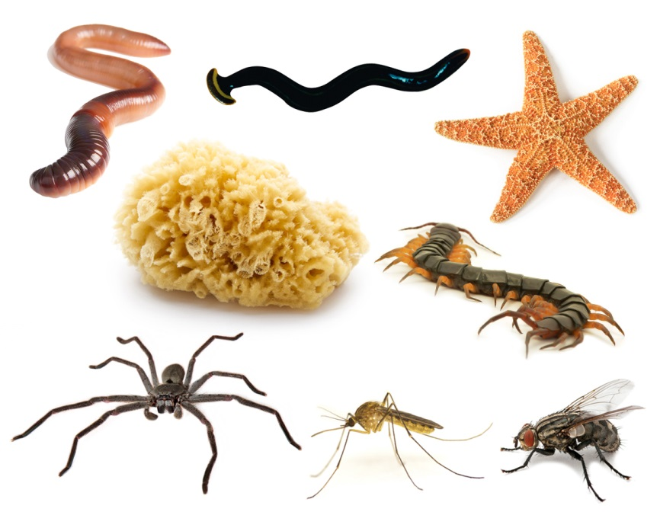

**Figure 1**

Experiment worksheet

5.7 Vertebrates can be organized into five Classes

Pages 92–93 and 197

Challenge 5.7: Who are the vertebrates?

What you need:

A3 paper, pencils

What to do:

**Vertebrate alphabet graffiti**

This task could also be completed as a webpage, with images and links to further information about each animal.

1 Divide the class into five groups, each of which will be allocated one class of vertebrate.

2 Label an A3 sheet of paper with the name of your class of vertebrate.

3 Write the letters of the alphabet down the left-hand side of the page.

4 For each letter, write the name of an animal that fits this category.

5 When finished, you will have the names of up to 26 different vertebrates. Some categories will be harder to fill than others.

6 Put the finished sheets up around the room.

**Jellyfish organiser for vertebrates**

A jellyfish graphic organiser is a good way to show how subgroups make up a whole. It can also be used to list specific examples at the same time.

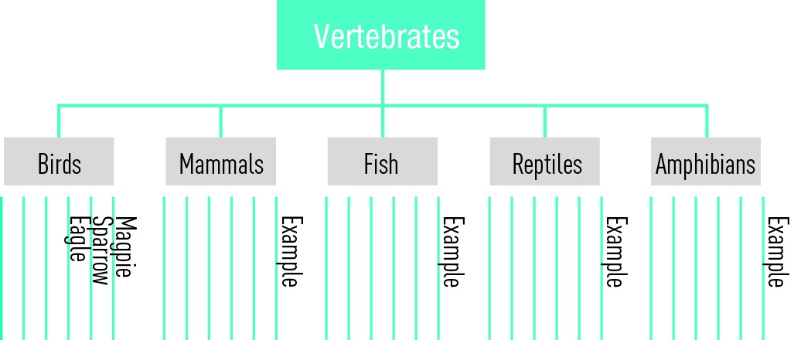

**Figure 1** A jellyfish organiser for vertebrates

1 Individually, go around to each of the five lists of vertebrates and select six animals from each class.

2 In the space provided, draw five ‘jellyfish’ connected to the main group (vertebrates), as shown in Figure 1.

|  |
| --- |
|  |

3 Label each jellyfish with the class name (fish, reptiles, amphibians, mammals and birds).

4 Write a description of the characteristics of each class in the appropriate body of each jellyfish.

5 Place the six animals you selected along the six tentacles on each jellyfish.

Experiment worksheet

5.8 Plants can be classified according to their characteristics

Pages 94–95 and 198

Challenge 5.8: Identifying plants

What you need:

camera, measuring tape, pencils, paper

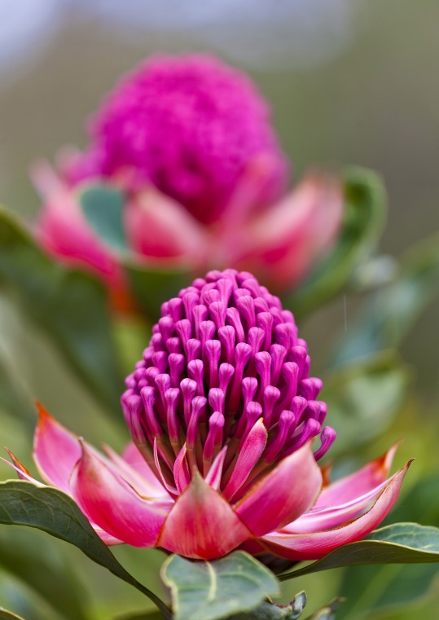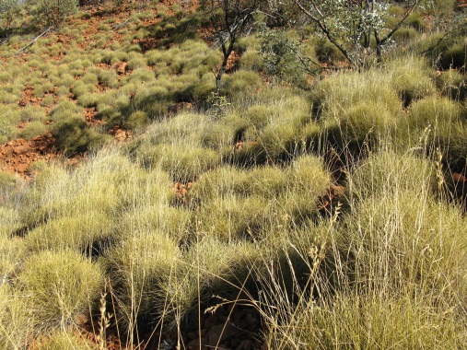

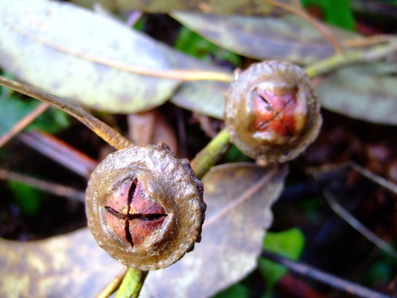

What to do:

1 Observe and take digital photos of at least five different types of plants from a local bushland or from your garden.

2 Fill out the table on the next page with detailed observations of each plant, including:

a the height of the plant

b the width of the plant

c the shape, smell, texture and size of the leaves (take a close-up photo of the leaves)

d the position and number of leaves on the plant.

3 Does the plant produce flowers, seeds or nuts? If so describe these.

4 Is there anything else unusual or special about this plant?

5 Repeat steps 2–4 for all the plants you observed.

|  |  |  |  |  |  |
| --- | --- | --- | --- | --- | --- |
|  | Plant 1 | Plant 2 | Plant 3 | Plant 4 | Plant 5 |
| Height |  |  |  |  |  |
| Width |  |  |  |  |  |
| Shape, smell, texture, size of leaves |  |  |  |  |  |
| Position and number of leaves |  |  |  |  |  |
| Flowers, seeds or nuts? |  |  |  |  |  |
| Special or unusual features |  |  |  |  |  |

6 What features did all the plants have in common?

7 What differences did you observe between the plants? Describe these differences.